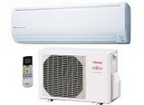
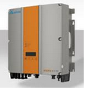
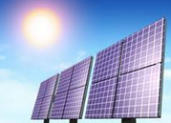
Worksheet 4: How solar works
- Here are a few elements: give their names
 |  | 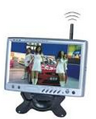 | 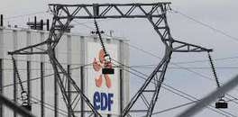  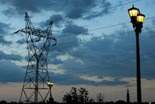 | 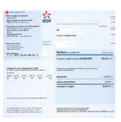

- Find out how the above elements can help rebuild the script, (listen carefully)
a. solar electricity is using technology that has been fully over many years.
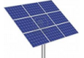
b. the sun’s light into electricity
c. an the current electricity into current, also current.
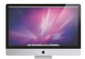
d. an optional bp solar and your system’s performances with your energy usage.
e. so, what can you see, at any time???? Make a full sentence please

- Find out the details…

- At night, or any time you ‘re than you are ,electricity will be from your

- And during the day , if you are electricity than the is back to the for an automated against your next

- Does all this make any difference in your house?? Answer using words from the text

- What is the last thing to be noticed however? Explain

